Pinellas Homeless Management Information System
Privacy Notice

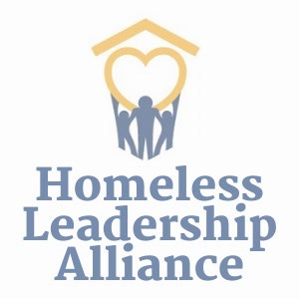
In accordance with Federal Regulations, each jurisdiction that receives local, state, and federal funding must have, and enter data into, a Homeless Management Information System (HMIS), which in Pinellas County is called Pinellas Homeless Management Information System, or Pinellas HMIS (Pinellas HMIS). In addition, each agency that participates in a collaborative client information system in accordance with F.S. 163 Part VI will notify clients of their participation.

Pinellas Homeless Management Information System (Pinellas HMIS) is a computerized system that collects, stores, and shares information about people who receive services from this agency. Since this agency is a Homeless Leadership Alliance Member Agency, it participates in the Pinellas HMIS. This client information system is used to determine your eligibility needs and provides this Member Agency a record for evaluating their services; only collecting information that is needed to provide you with the appropriate services.

Data is collected and shared, with your written or verbal consent when you meet or speak with this Member Agency. You are giving consent for this Member Agency to access, enter, and share your personal information in the Pinellas HMIS. Data may be shared without your consent in instances of serious threats to health or safety if we believe that the use or disclosure is necessary to prevent or lessen a serious and imminent threat to the health or safety of an individual or the public (HMIS Data and Technical Standards Final Notice § 4.1.3).

The collection and use of all personal information is protected by strict standards of confidentiality as outlined in writing in the Pinellas Homeless Management Information System Policies and Procedures Manual.

Data will only be reported in aggregate, non-identifiable format for research purposes. No personal data is disclosed for administrative or research purposes except to other Homeless Leadership Alliance Member Agencies. Individually identifiable personal information is only disclosed in accordance with your authorization or as authorized by law. No client data collected is ever sold.
A copy of this Privacy Notice is available upon request for your review.

